Conference Management System

User Manual

Pulling Repository from GIT.

Go to https://git.infotech.monash.edu and copy the html URL of the repository. The URL of the repository is https://git.infotech.monash.edu/fit5136-s1-2021/team-48-repo.git
Paste this URL in the Command Prompt of the VS Code and select a destination folder on the desktop to save the repository. Once all the steps are done, perform a Pull from the Repository. The pull can be performed by:
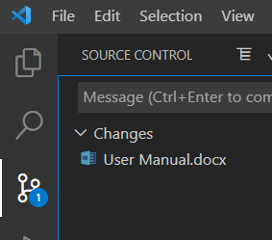
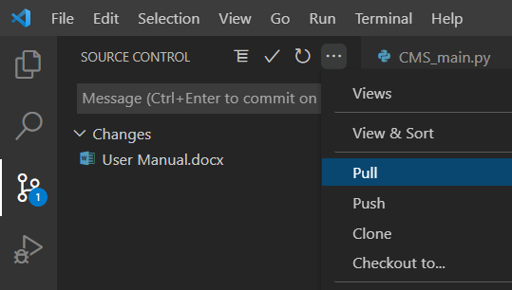
All the code from the repository will now be available in the VS Code. All the steps are similar if you are using PyCharm.

Running the Program

From the explorer tab, select the file ‘CMS_main.py’.
When the file is open, there is a Run button on the top right side of the explorer.
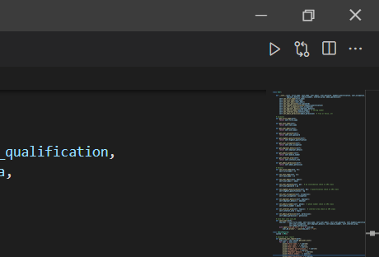

Click the 1st option as shown in the annotation above and you will get 2 options.
The two options are:
- Run Code
- Run Python File in Terminal
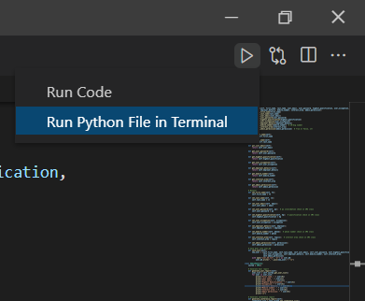

Click on ‘Run Python File in Terminal’.
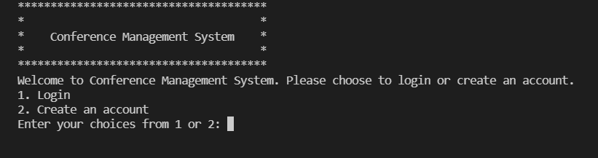

If you get this in the terminal below, your code is successfully running.

Creating an Account

When the code starts running and you get an output. You get 2 options to choose from
1: Login
2: Create an Account

Since we always need an account to access any application, we will start the process of creating an account first. In the input, press 2 and press Enter.
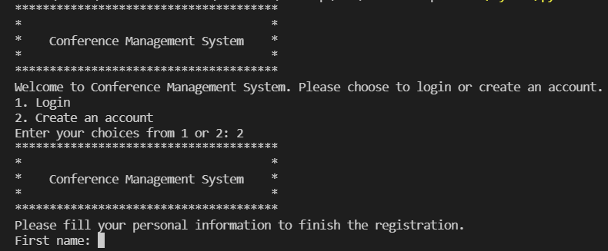

The Program will ask you to enter your details. We expect you to provide us with valid and real information as your information will be safe and secure with us. We have tried our best to add validation to the user input.
The details we will ask you for are:
First Name: Where you provide us with your given name.
Last Name: Where you provide us with your family name.
Email: A valid email ID which you will be using to login to our system.
Password: Should be 8 Characters long with at least 1 Upper case, 1 Lower case and 1 number.
Highest Qualification: Select 1 option which applies to you. If you have completed Masters so you select 4.
Occupation: What you work.
Employer Details: Where you work.
Mobile Number: Should be 10 digits only.
Interest Area: Select 1 option you are interested in. If you are interested in Cyber Security, you press 2 and press enter.

Once all the data is entered, the application will ask you whether you want to submit the details. So, the options are:
- Submit your registration.
- Cancel registration and return to main page.
If you want to submit your registration, you press 1 and enter. If you want to cancel the registration, you press 2 and enter. If you press enter, your personal details will be saved in our database.
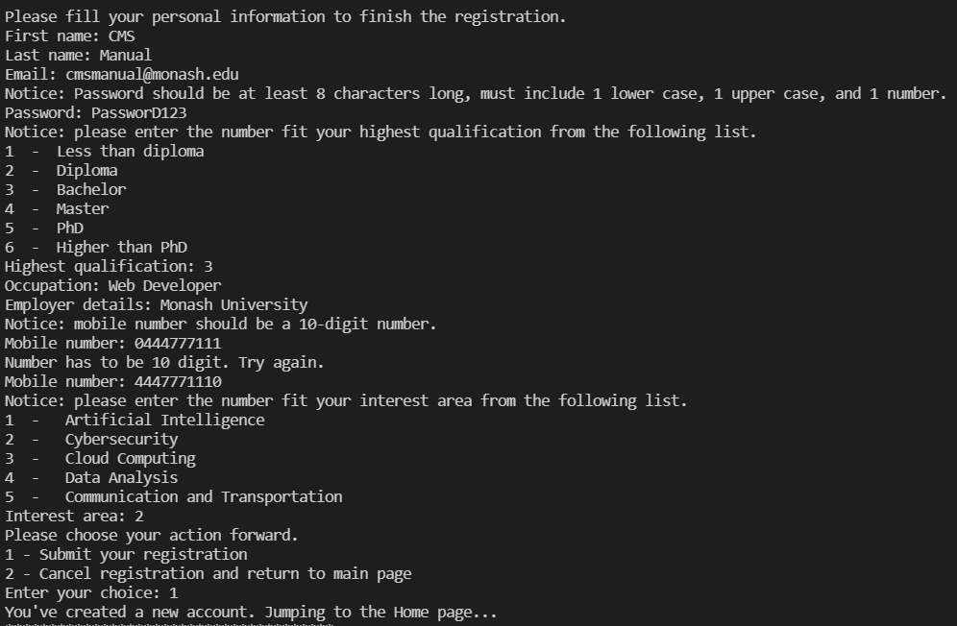
Congratulations, your account has now been created. You can use your details to login to the application.

Login to the System

If you have a valid account to login to the system, you need to follow the step 2 in this user manual or if you have created an account, you will be directly logged in the system. Once you have completed the steps given in Step 2 you will have this output.
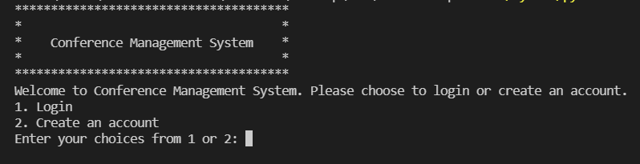
We will press 1 to login to the system.
Note: If you do not have valid login details, you will not be able to access the features of this system.
From the options given above, press 1 and enter.
The system will ask you for the following.

Email: Enter your email ID which you had used to create an account on this application.
Password: Matching Password with the email. If you have 2 accounts on this system, it is not necessary that the other account’s password will help you authenticate into the system unless they are the same.
Do you want to login by this credential? Y/N: If you want to login using these credentials, press Y and enter. If you changed your mind about logging in to the system press N and enter.

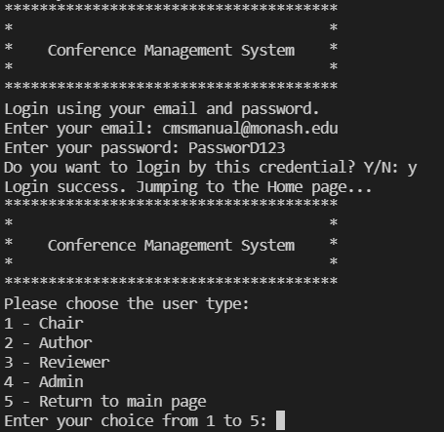
On successful login verification, you will be logged in to the system and access the features of the application.
For testing Admin features, you can use xd@monash.edu in our sample database user_db.txt to login.
For testing Chair features, you can use jb@monash.edu in our sample database user_db.txt to login.
For testing Author features, you can use asd@123.com in our sample database user_db.txt to login.
For testing Author features, you can use 123as@dASD.com in our sample database user_db.txt to login.

Logging in as a Chair

To login as a chair, you need to follow the steps mentioned in step 4 to login. Once you have successfully logged in to the system, you select option 1 out of the 5 available options to login as a chair.
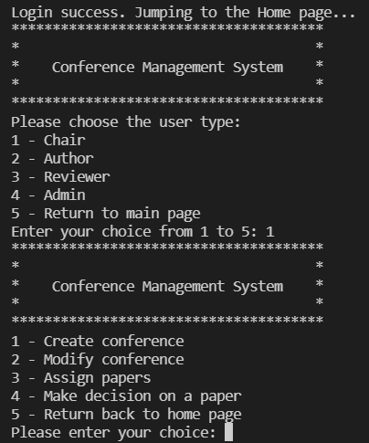
For a chair, there are 4 options available.

5.1 Create Conference.

To create a conference, we select the 1st option as given in the above image.
To choose the 1st option, we press 1 and enter.
The system will ask you to the following inputs:

Enter Conference Name: The name of the Conference you want to set.
Conference Title: The conference title should be Artificial Intelligence/ Cybersecurity/ Cloud Computing/ Data Analysis/ Communication and Transportation. If you enter anything other than these 5 options, the system will give you an error and will ask you to select out of the 5 options. You can select any 1 of the 5 Title you want to.
Deadline Year: The year deadline you want to send for this conference. Should be a number only.
Deadline Month: The month deadline you want to send for this conference. Should be a number only.
Deadline Day: The day deadline you want to send for this conference. Should be a number only.
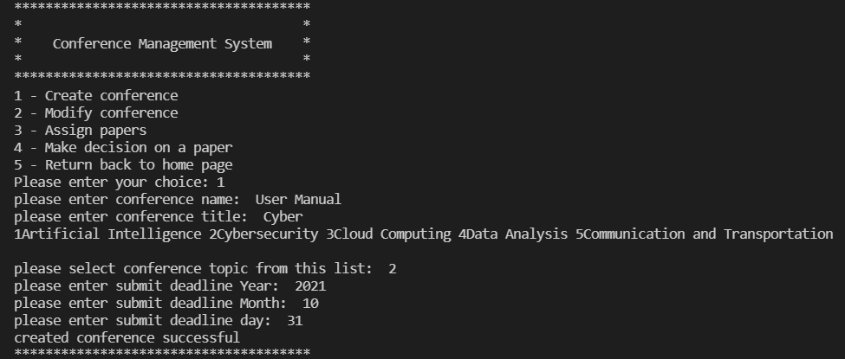
Once all the input are successfully entered, you have created a conference as a chair.

5.2 Modify Conference.

If you want to modify a conference, you must select the 2nd option – Modify Conference when logged in as a Chair.
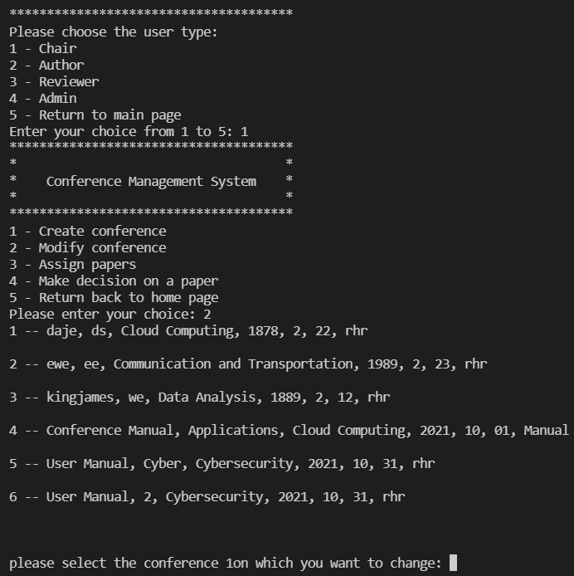

As a chair, you can select any 1 of the conference you want to modify.
You will get an option to modify the Conference Details.
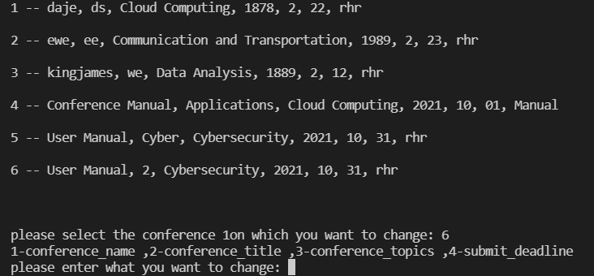
If you select:
- Conference Name: You can change the name of the conference.
- Conference Title: You can change the title of the conference.
- Conference Topics: You can change the topic of the conference.
- Submit Deadline: You can change the deadline of the conference.
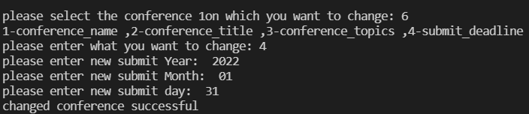
Once the change is done, we will get an output such as shown in the image above.

5.3 Assign Papers

If you want to modify a conference, you must select the 3rd option – Assign Papers when logged in as a Chair.
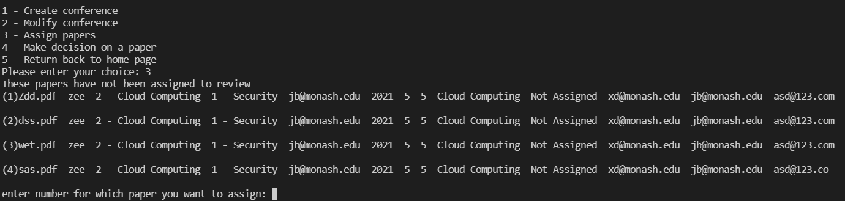
Then select the paper you want to be assigned to a reviewer. You have to select 3 reviewers to review the papers. So, you will get an option to assign a person as a first reviewer, then a second reviewer and then a third reviewer. Once these papers are assigned to the reviewers, the system will return Assign Successful.
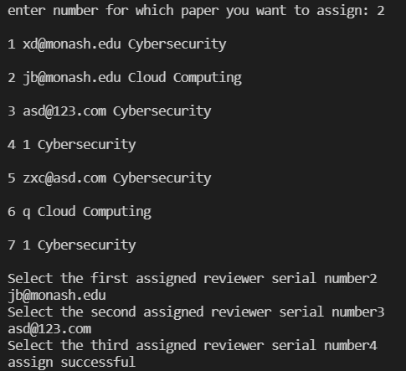

5.4 Make Decision on a Paper.

If you want to decide on a paper, you must select the 4th option – Make Decision on a Paper when logged in as a Chair.
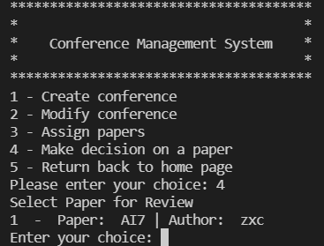

When you select the option, you will get paper’s which are reviewed by the evaluator and are now to be evaluated by the chair.
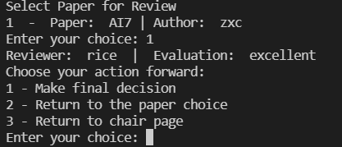
A chair can then perform 3 actions – Make Final Decision, Return to the paper choice and return to chair page. A chair can then make a final decision. It will then ask the chair whether to Accept, Reject or return to the previous page.
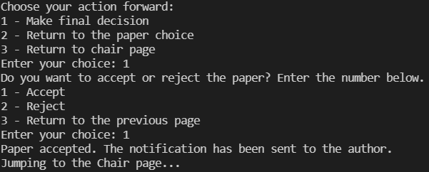
A notification will be sent to the author when a chair performs an action.

Logging in as an Author

To login as an author, you need to follow the steps mentioned in step 4 to login. Once you have successfully logged in to the system, you select option 2 out of the 5 available options to login as an author.
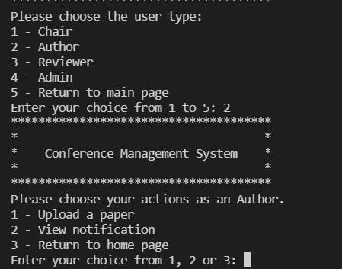

For an author, there are 3 options available.

Upload a Paper.

If you want to decide on a paper, you must select the 1st option – Upload a Paper when logged in as an Author.
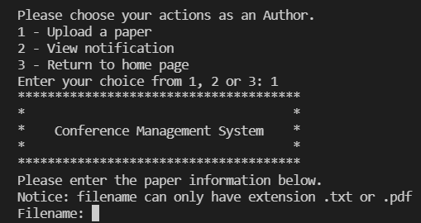
When you select option 1 to upload a paper, you will get an option to enter the filename. The filename should either be .txt file or .pdf file. Other file names will not be uploaded.
The Author will then have to add the Paper Title.
Then the Author should enter the Paper Title. Paper Title should be Artificial Intelligence/ Cybersecurity/ Cloud Computing/ Data Analysis/ Communication and Transportation. If you enter anything other than these 5 options, the system will give you an error and will ask you to select out of the 5 options. You can select any 1 of the 5 Title you want to.
The system will then ask for the keywords to be added to the paper. The keywords are:
1 - AI
2 - Security
3 - Cloud Computing
4 - High Performance
5 - Data
6 - Protocol
7 - Neural Network

The system will ask whether to add more keywords to the paper. You can press either Y or N depending on whether you want to add the keywords or not. Then you have to select the conference you want to add the paper into.
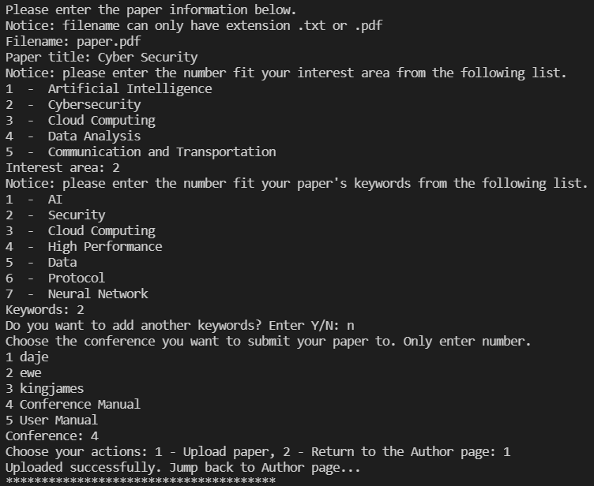
Once you have entered the conference, the system will ask whether you want to upload the paper or return to the author page. To upload the paper, you will press 1 and upload the paper.

View Notification.

If you want to decide on a paper, you must select the 2nd option –View Notification when logged in as an Author.
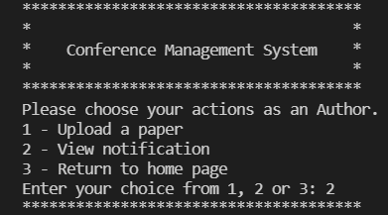
Once you select the 2nd option, the system will display all the notifications.
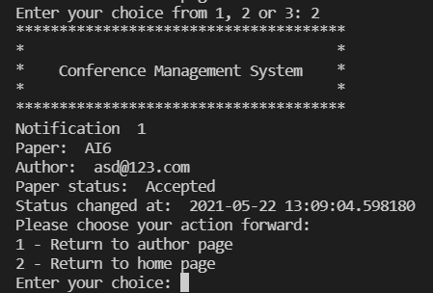

Logging in as a Reviewer

To login as a reviewer, you need to follow the steps mentioned in step 4 to login. Once you have successfully logged in to the system, you select option 3 out of the 5 available options to login as a reviewer.

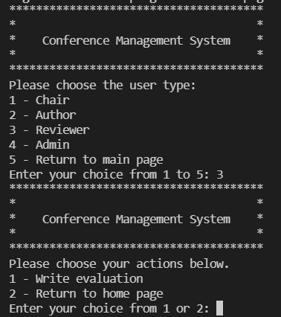

The reviewer has an option to write evaluation to the paper assigned to him by the chair. To write an evaluation, you press 1 and enter. You will get the options to review all the papers which you were assigned, and you can select any one of the paper to evaluate.
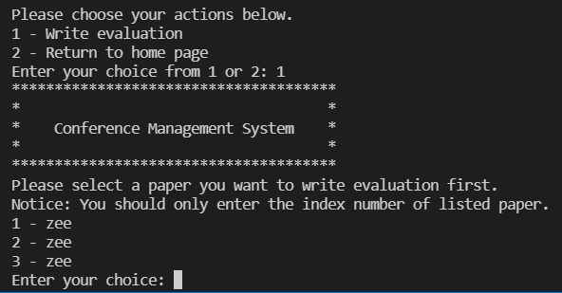
Once you have selected the paper, you will be displayed with the paper you have chose and your name, and then you can input your evaluation.
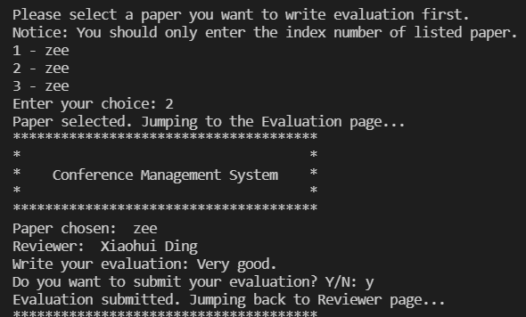
Once you have added your evaluation, you get an option of submitting the evaluation. If you want to submit it, press Y and enter else press N and enter. The review will then be submitted after Y input has been given to the application.

Logging in as an Admin.

To login as an admin, you need to follow the steps mentioned in step 4 to login. Only pre-defined Admin can use admin features, so if you want to use admin features, please contact the backend front admin.
Once you have successfully logged in to the system, you select option 4 out of the 5 available options to login as an admin.
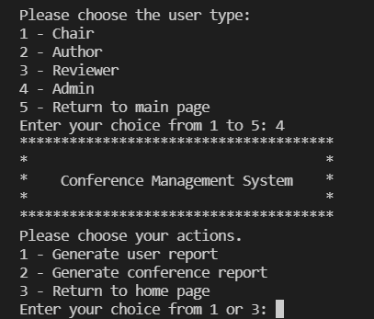

The admin has an option to view the user reports and the conference reports. To generate the user reports, you must press 1 and enter.
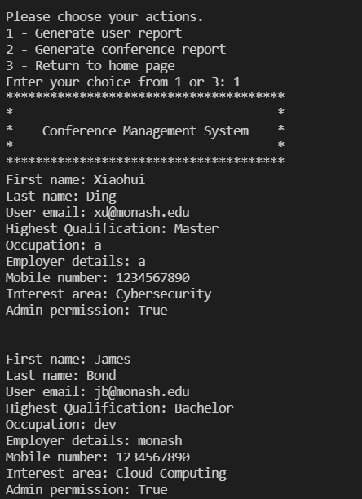

This will generate all the users registered in the user database.
Similarly, to generate the conference reports, you must press 2 and enter.
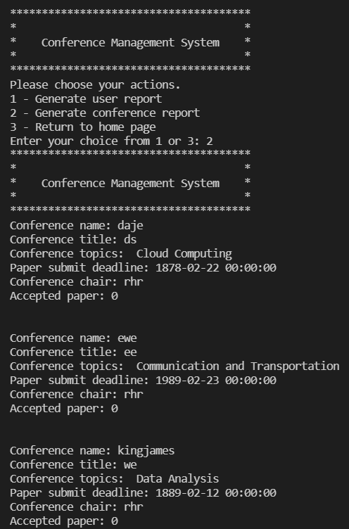
This will generate all the conferences created by the chair.

